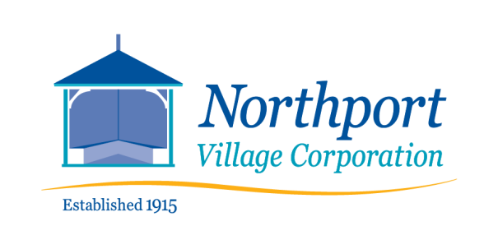
Bayside Wastewater Department
Temporary Moratorium on New Connections
DATE: _________________ (Draft)

The Utility Trustees hereby impose a Moratorium upon the receipt and processing of any sewer connection permits or any other application for other permits of any type which requires a new connection to the Northport Village sewer system, for the purpose of evaluating the systems efficiency and efficacy in removal of TSS and BOD and to determine if improved testing and removal mechanisms may be identified and/or implemented.
This moratorium shall be in place from MM DD, 2022 until MM DD, 2022, (no more than 6 months) and may be lifted sooner by an affirmative vote of a majority of the Utility Trustees.
This moratorium imposed shall be subject to the following exceptions:
A. This moratorium shall not apply to sewer connection permits approved prior to MM DD, 2022.
B. This moratorium shall not apply to the processing and issuance of any permit or approval for a project that does not require any new connections to the Northport Village sewer system.

